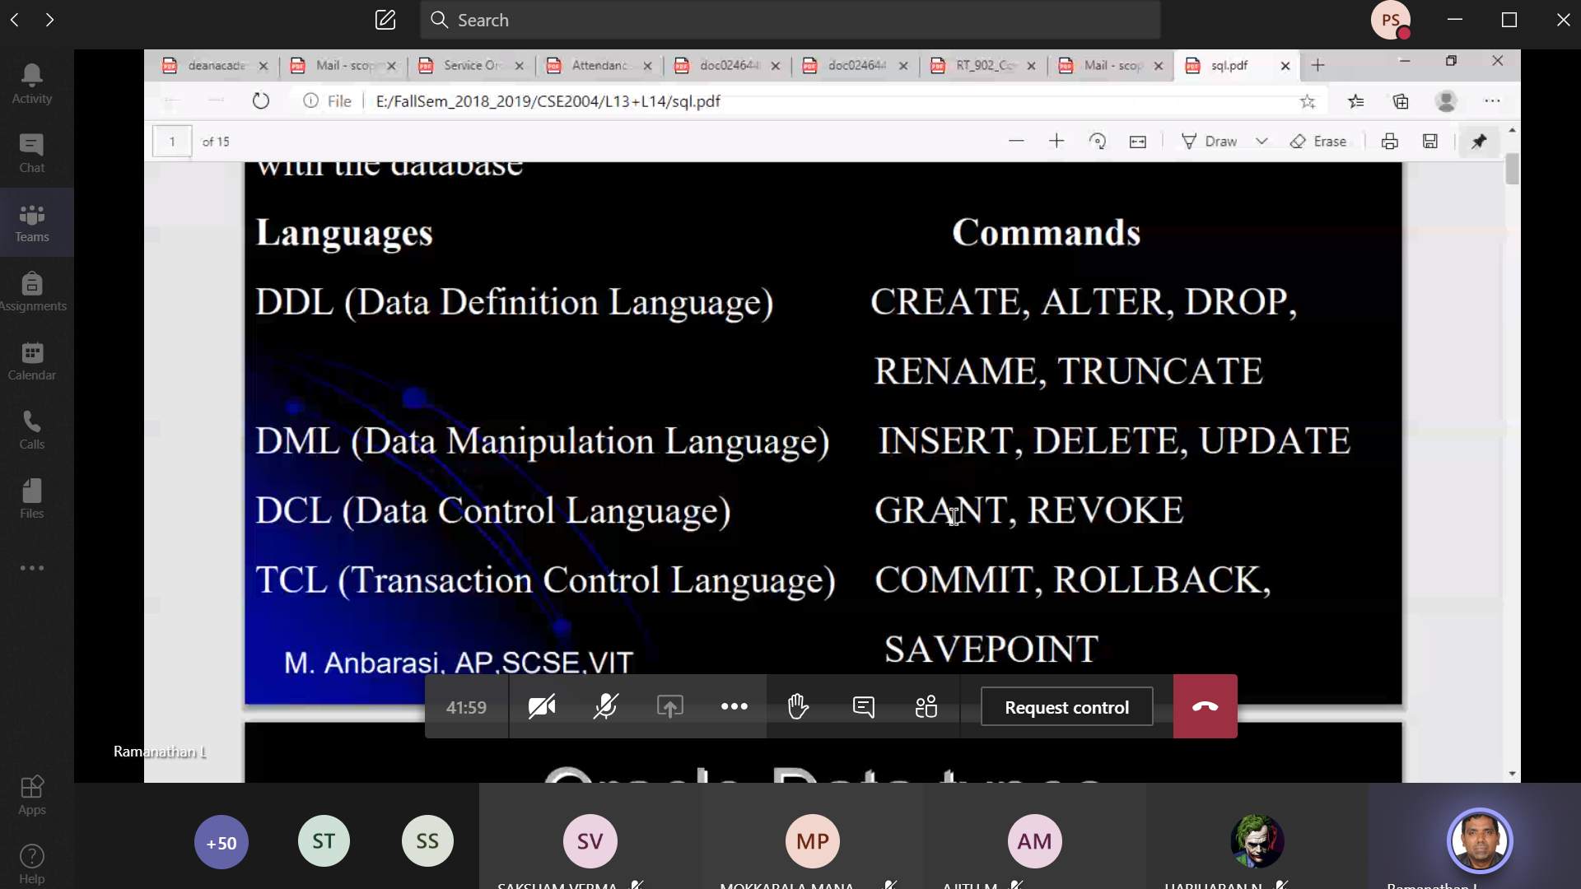

Drop 🡪 All the table, records will be deleted permanently

Delete 🡪 Delete’s a particular record from the data-base

Alter 🡪

Rename 🡪

Truncate 🡪 All the records will be deleted but the table structure will be maintained for future data.

Grant 🡪 Giving the permission

Revoke 🡪 Taking back the permission

Commit 🡪

Rollback 🡪 To identify the last Commit

Savepoint 🡪 1)

.



1000) If any problem between 1 to 1000, we can search and

look into instead of searching throughout the entire data-base

**Savepoint1**

1000)

.



2000)

**Savepoint2**

Eg : Amount paid but the bill is not generated. The DBMS guy will look upto which point the bill is not created with the help of Save-point . Eg: between 1000 to 2000 , he can look into it without searching the entire data-base

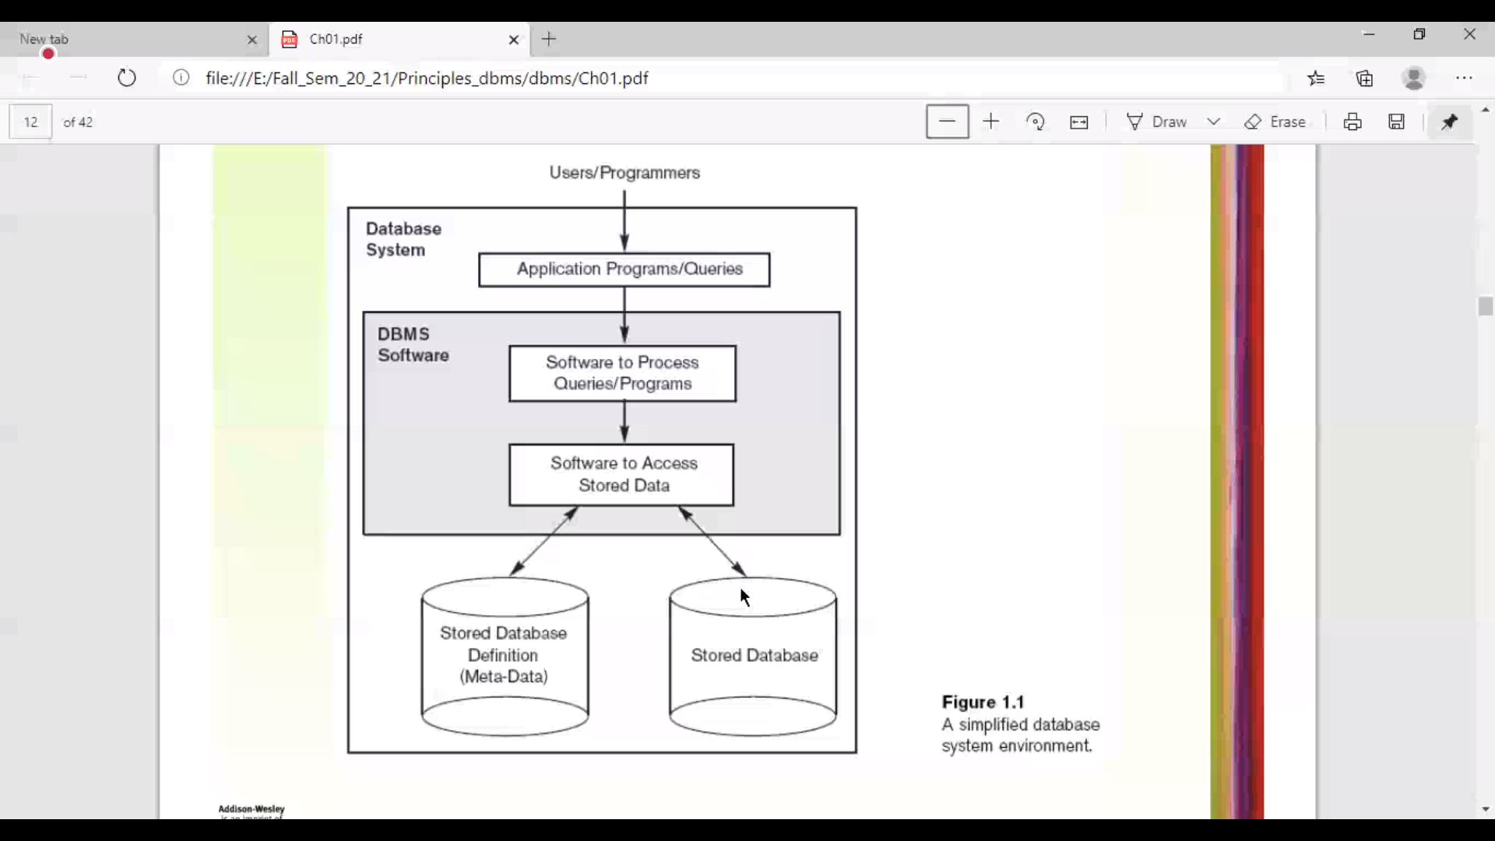

See from bottom to top

Meta-data and schema is same

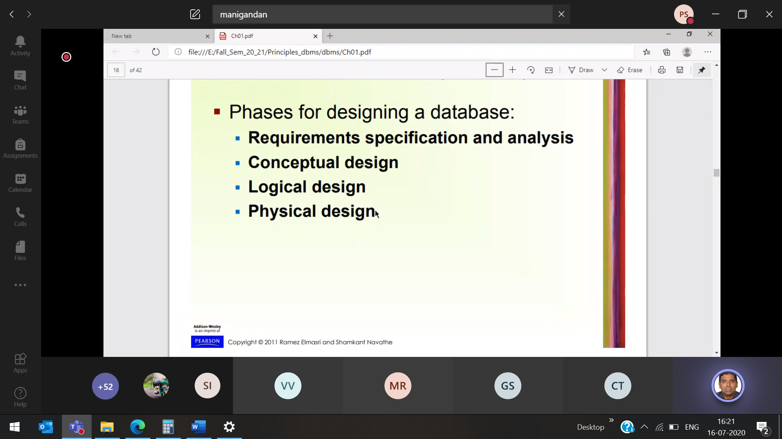

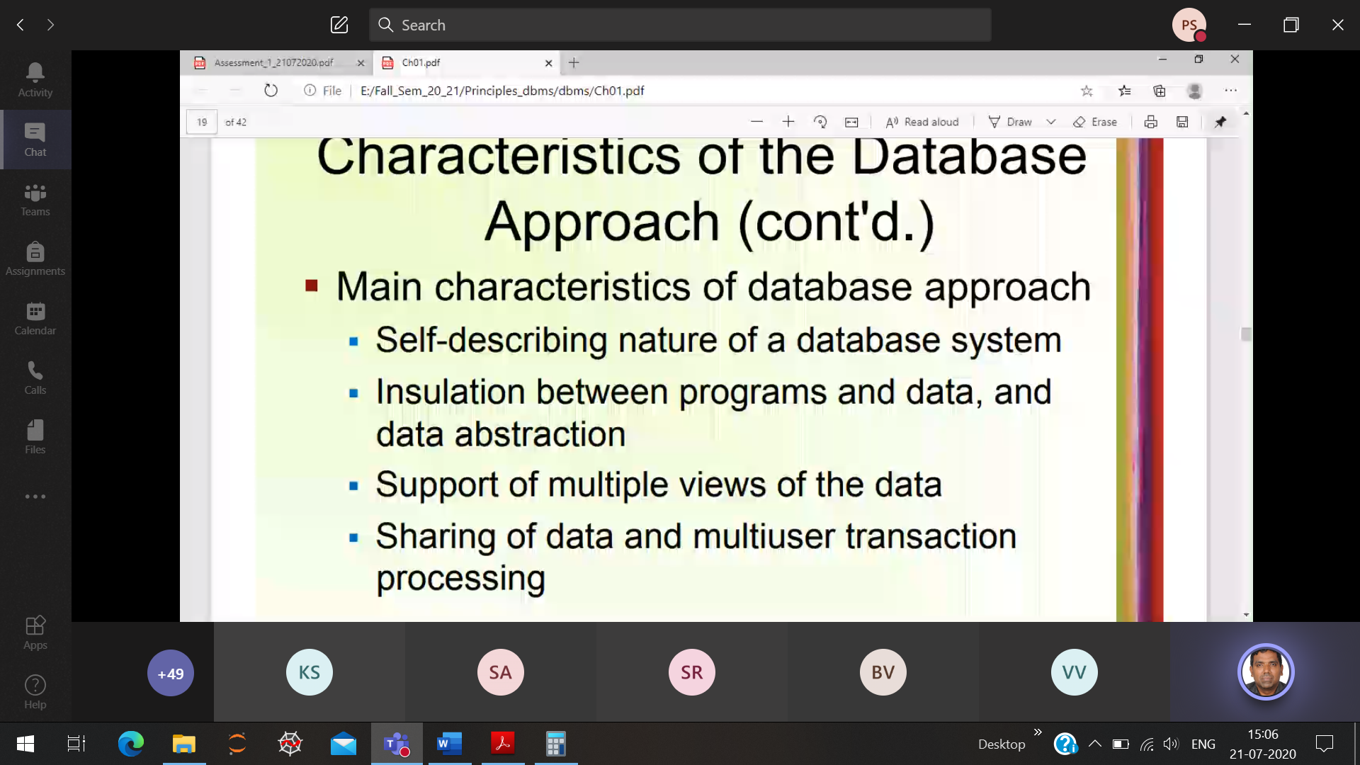

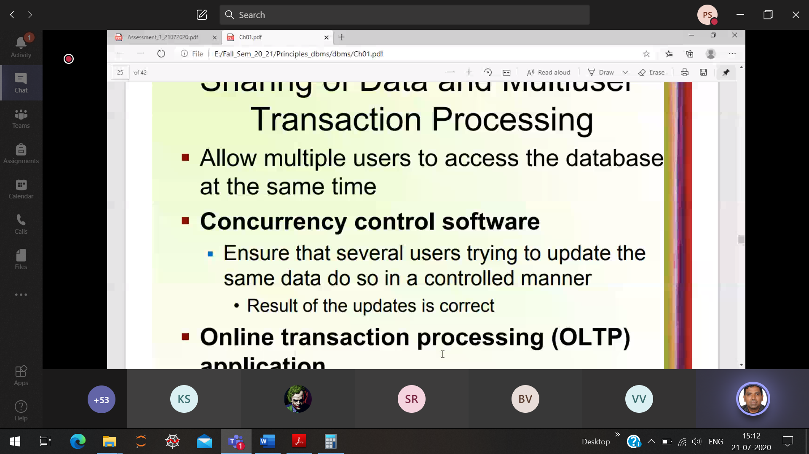

When several user are trying to update the same data. Eg: Booking train ticket simultaneously

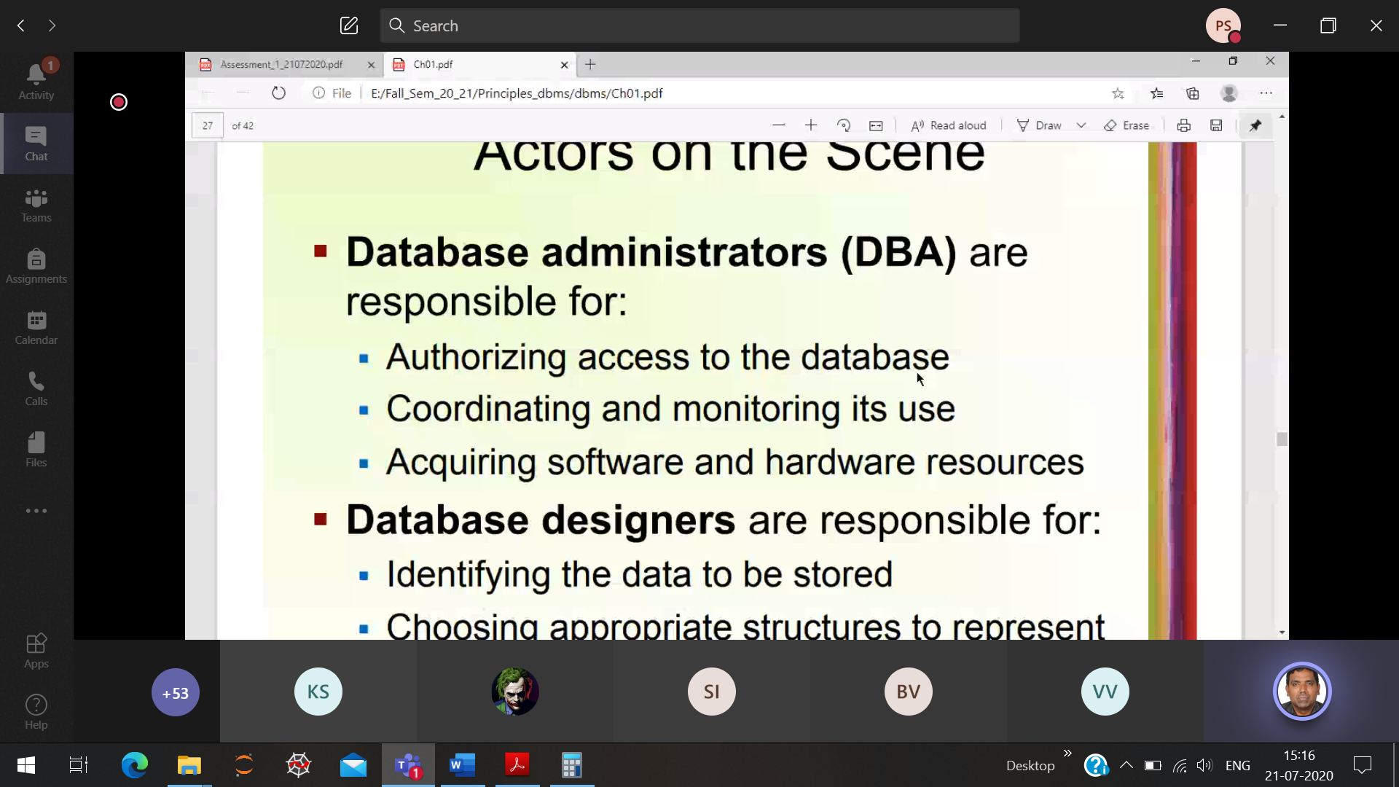

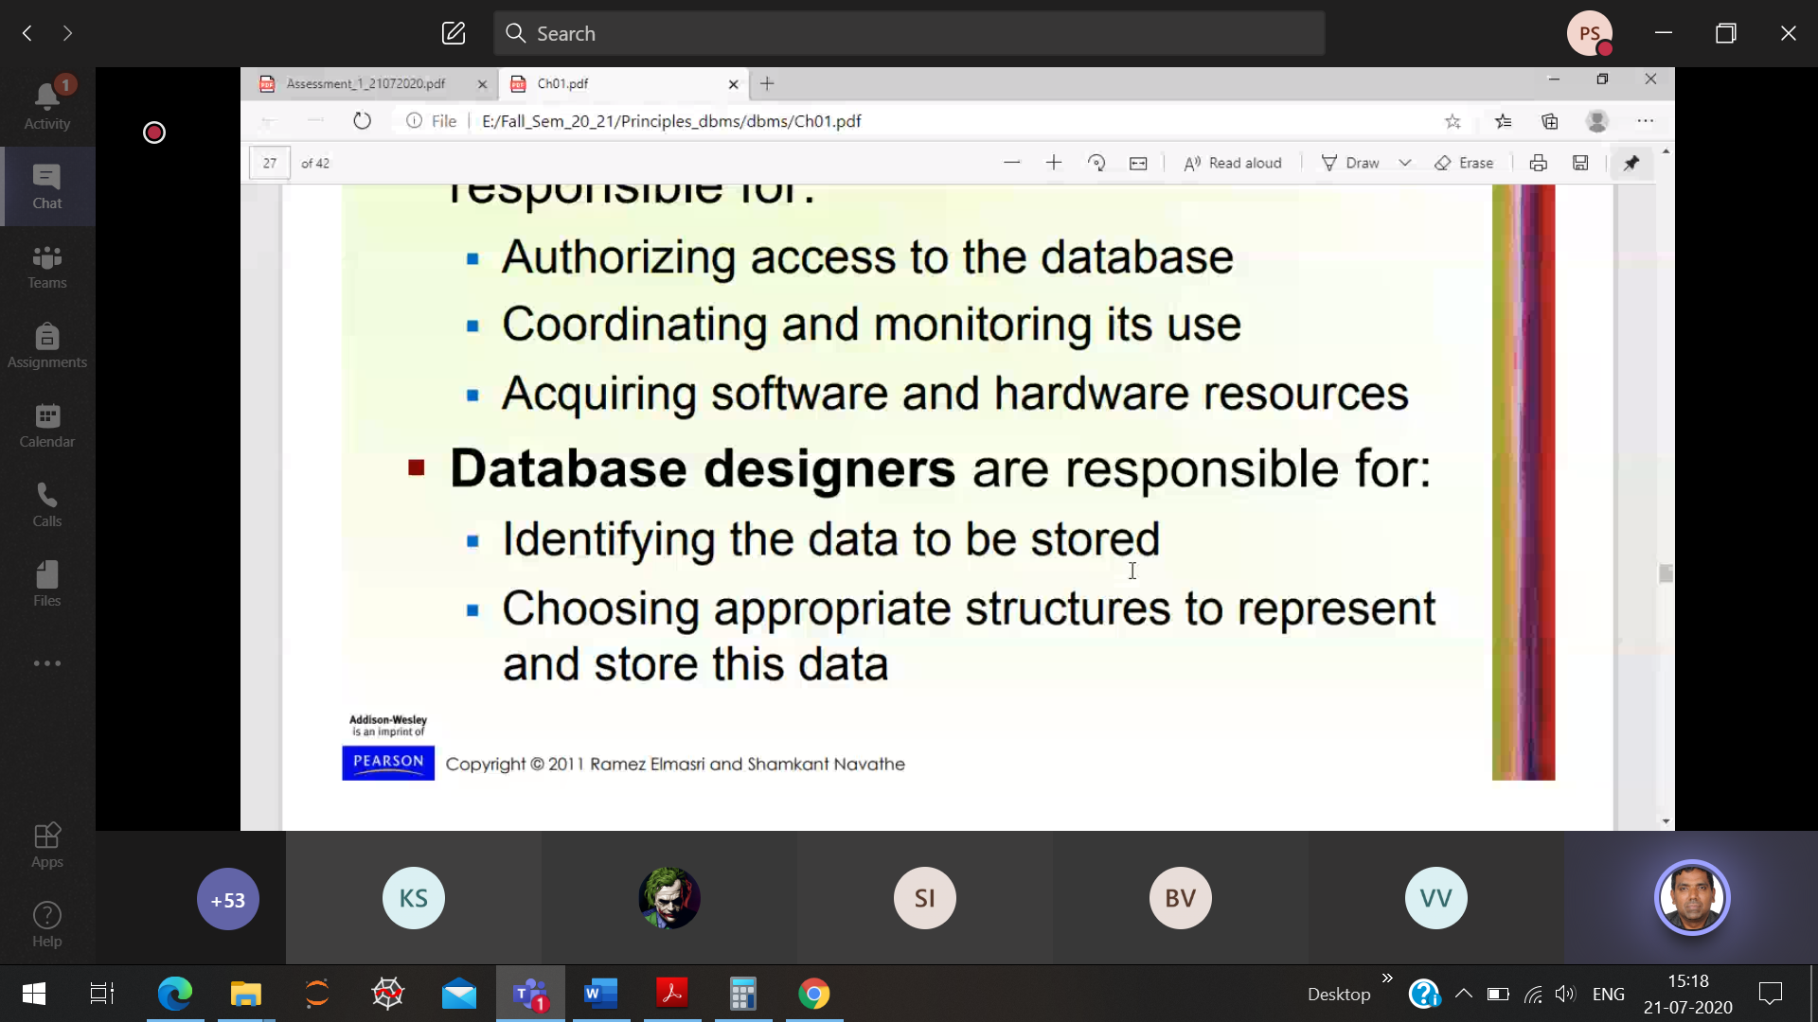

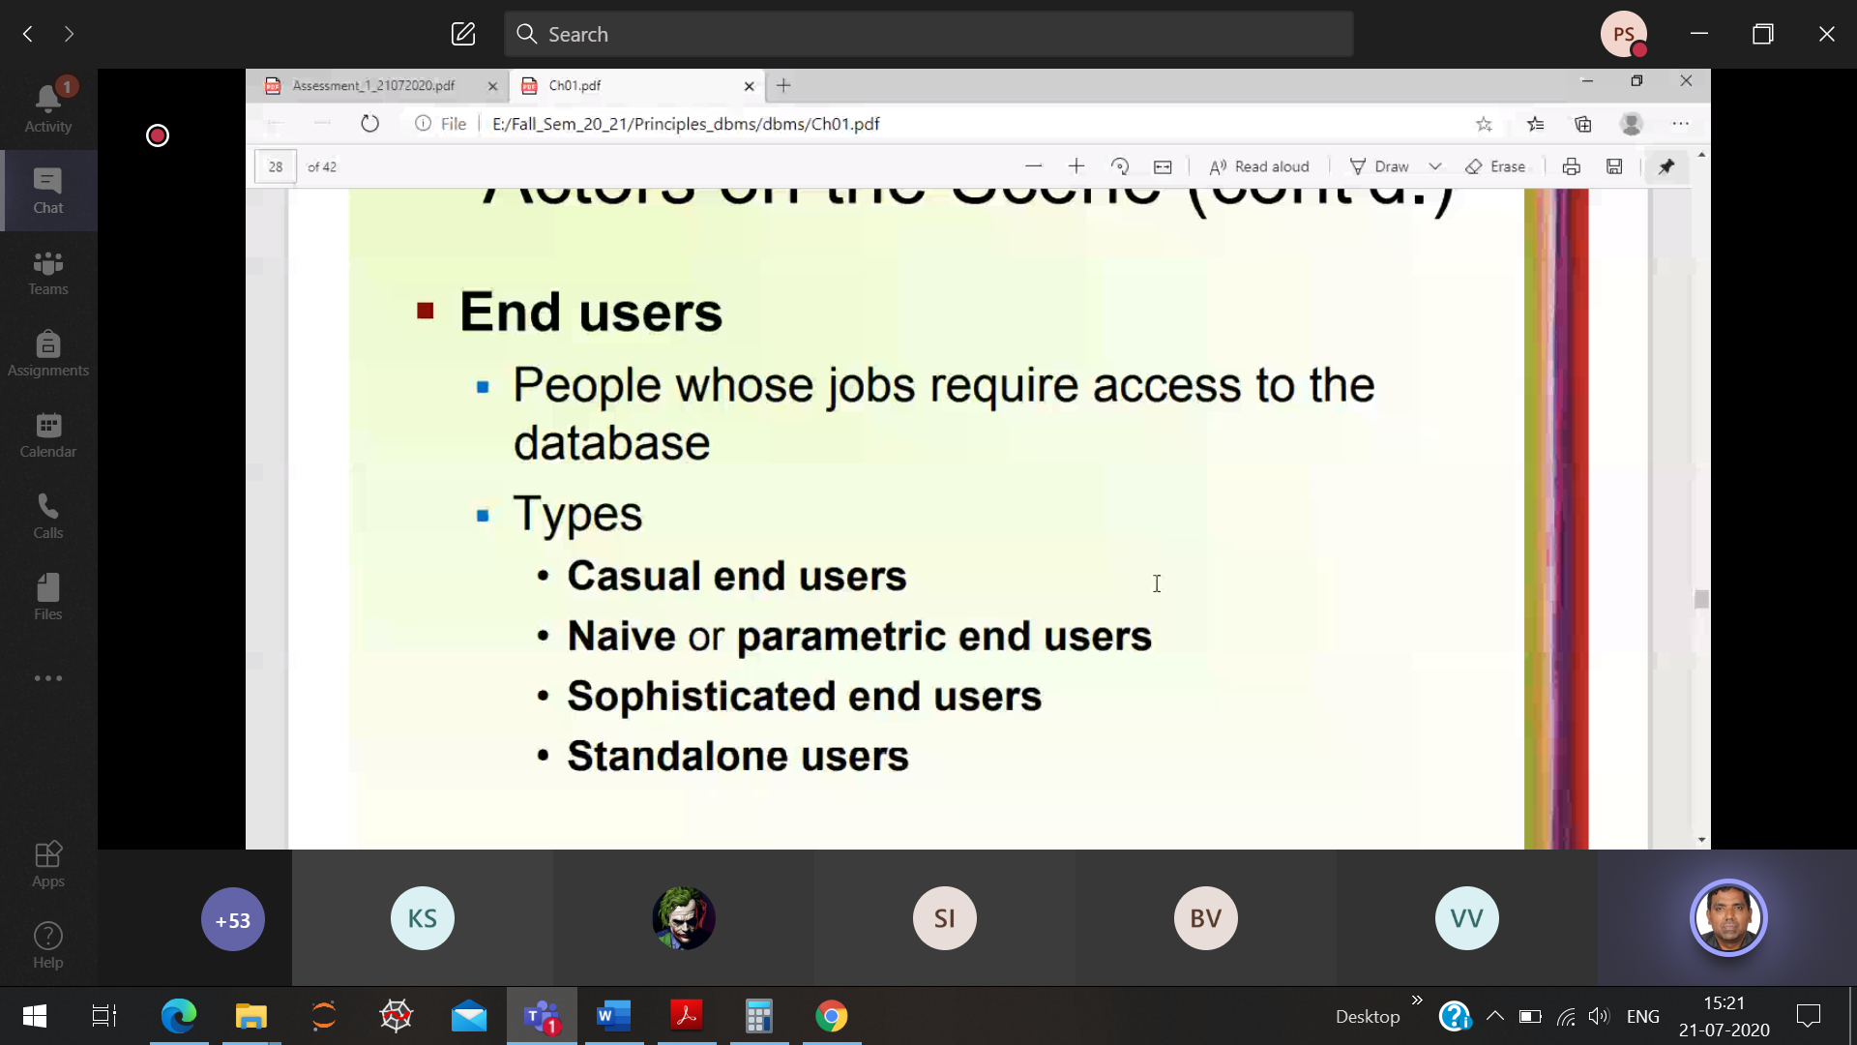

Casual end-user 🡪 Will access the data-base very rarely

Naive (or) Parametric end user 🡪 Bank employ user-interface screen will be completely different from customers user interface

Sophisticated end-user 🡪 User is familiar with many data-bases like oracle, my-sql

Standalone user 🡪 we the students, installed the oracle 🡪 we access both the server and client for practice

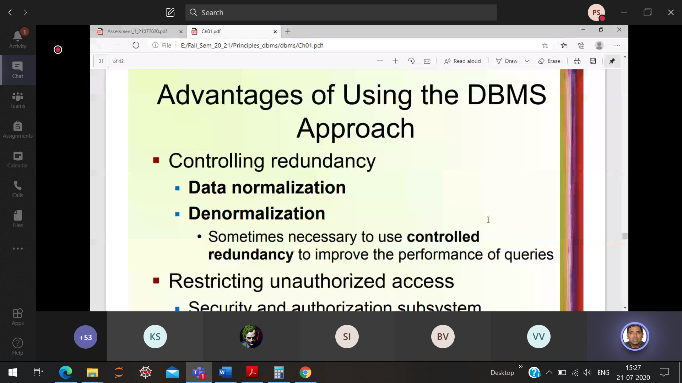

Avoid duplicate data’s

Prashanth 1) Hostel office 🡪 d1

2) College 🡪 d2

3) Finance department 🡪 d3

4) Mess 🡪 d4

In-order to avoid confusion Roll number 19MID0020 🡪**D**

After this each department will store the data only once to reduce the redundancy

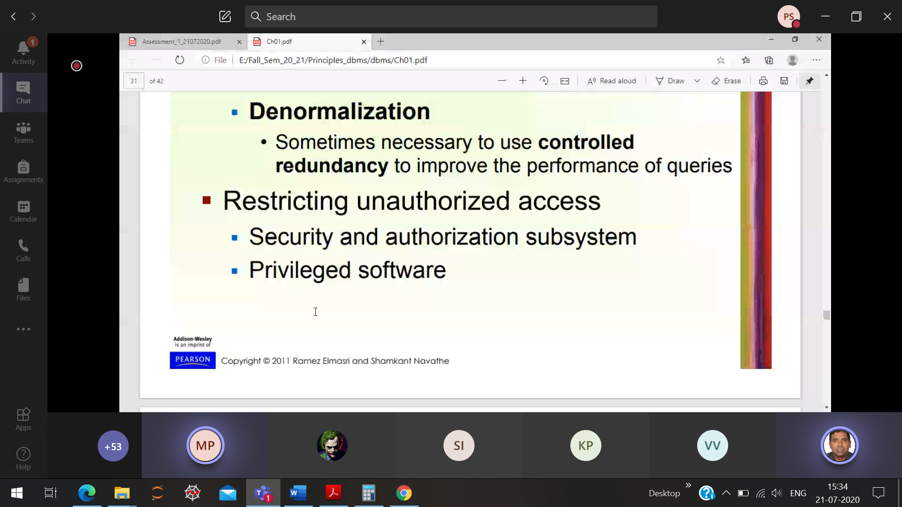

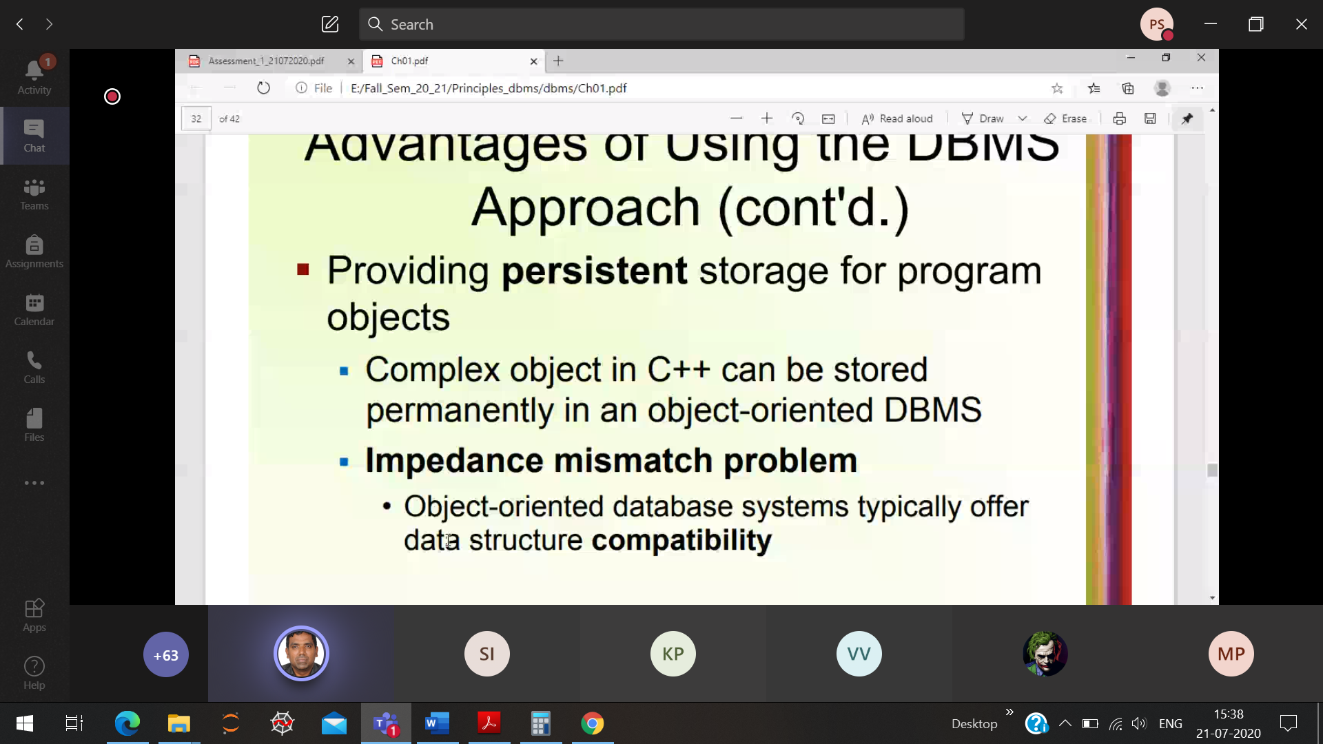

**Persistent storage**

Eg: Running a C/C++ program 🡪 Compiling and executing the code for 10th time with specific input and output. We can only view the current input and output, the previews results are not stored

But In DBMS all the alterations are recorded for future purpose.

**Impedance mismatch:**

**Eg:** Saravana bhavan India schema-1

Saravana bhavan UK schema-2

Saravana bhavan USA schema-3

All the three continent hotels profit, sales, preparations are different. But we can corelate the 3 schemas can be clubbed together using Data-Base.

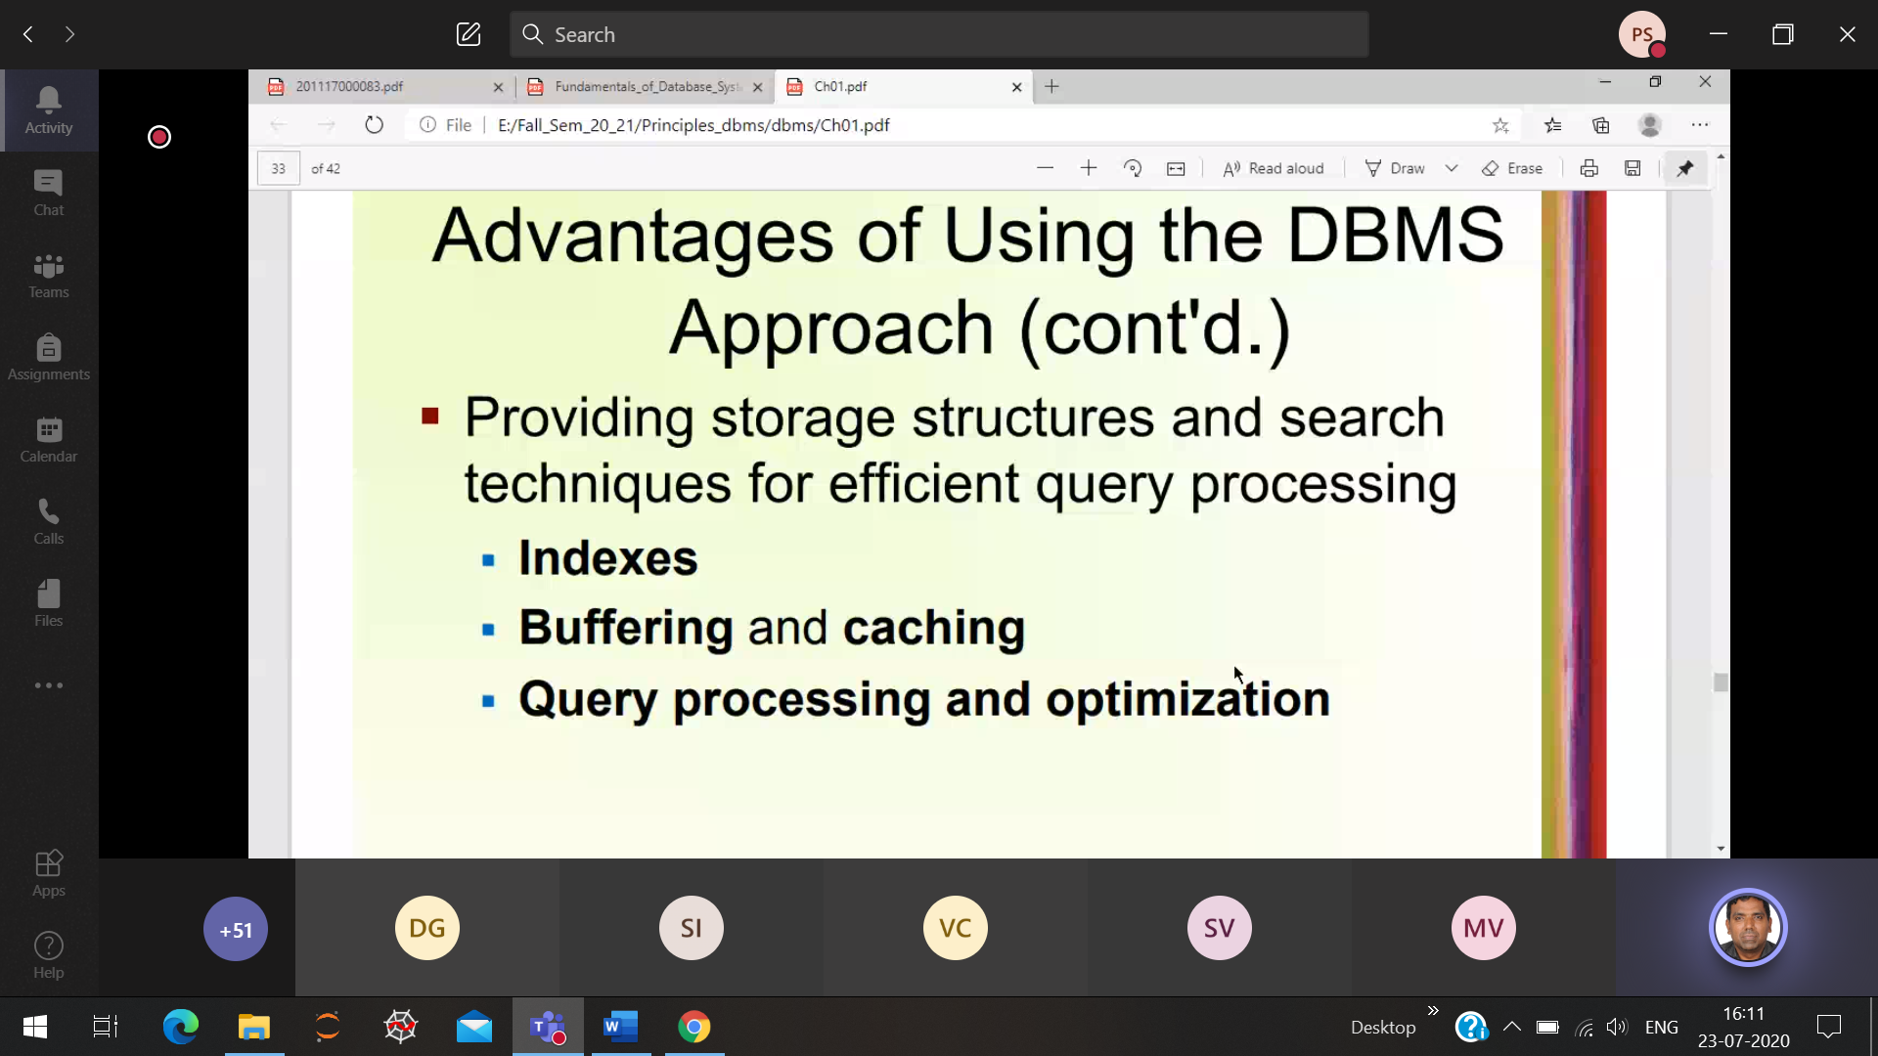

Select employ name whose getting salary>5000

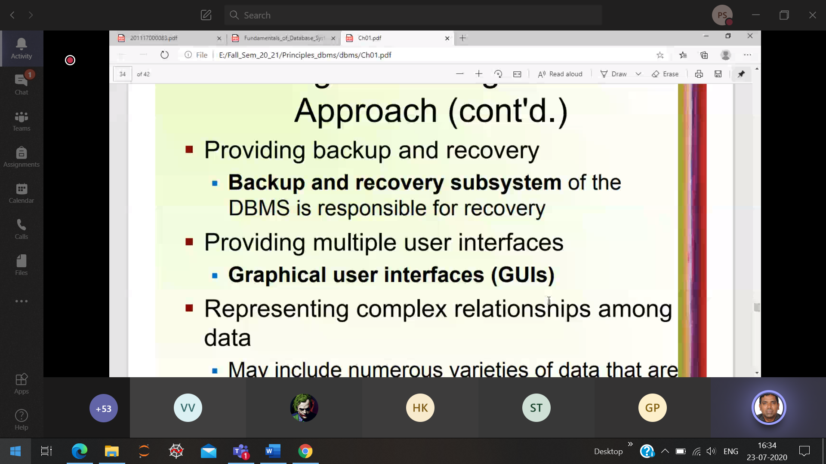 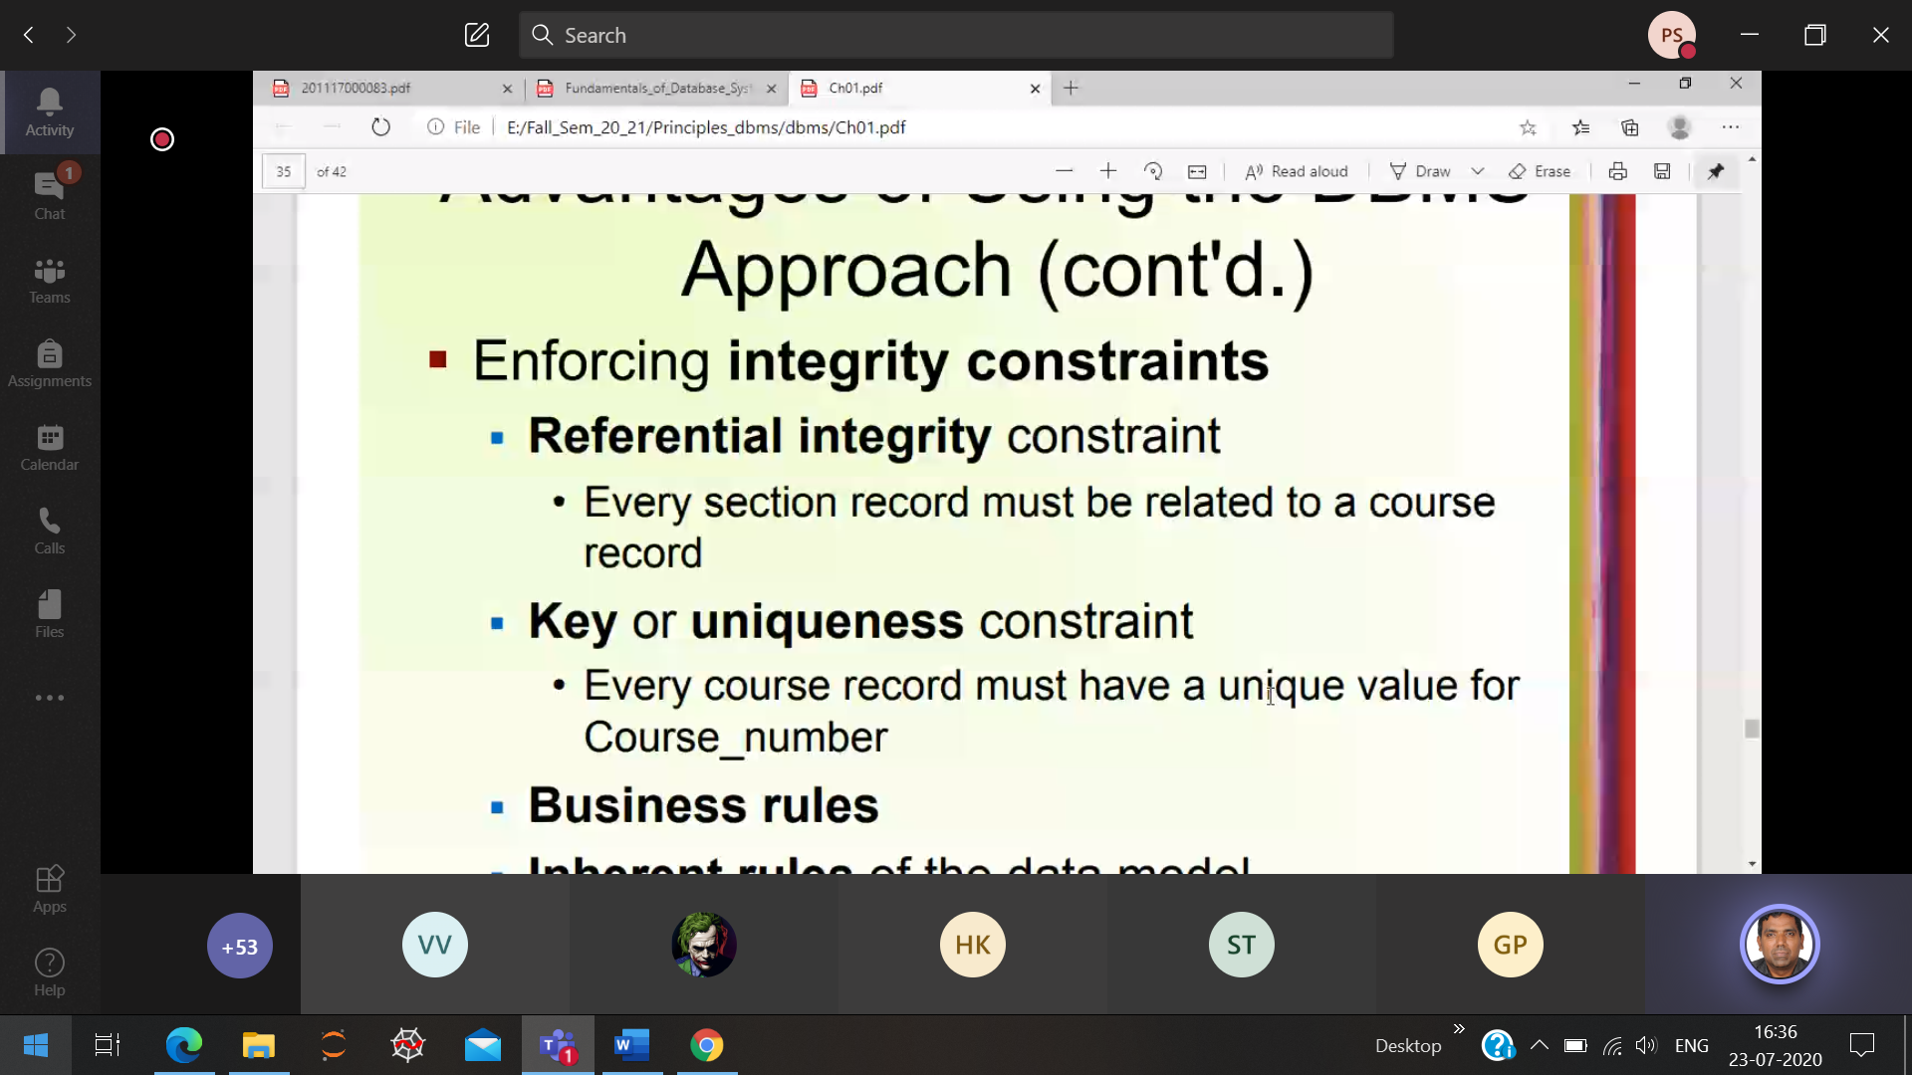

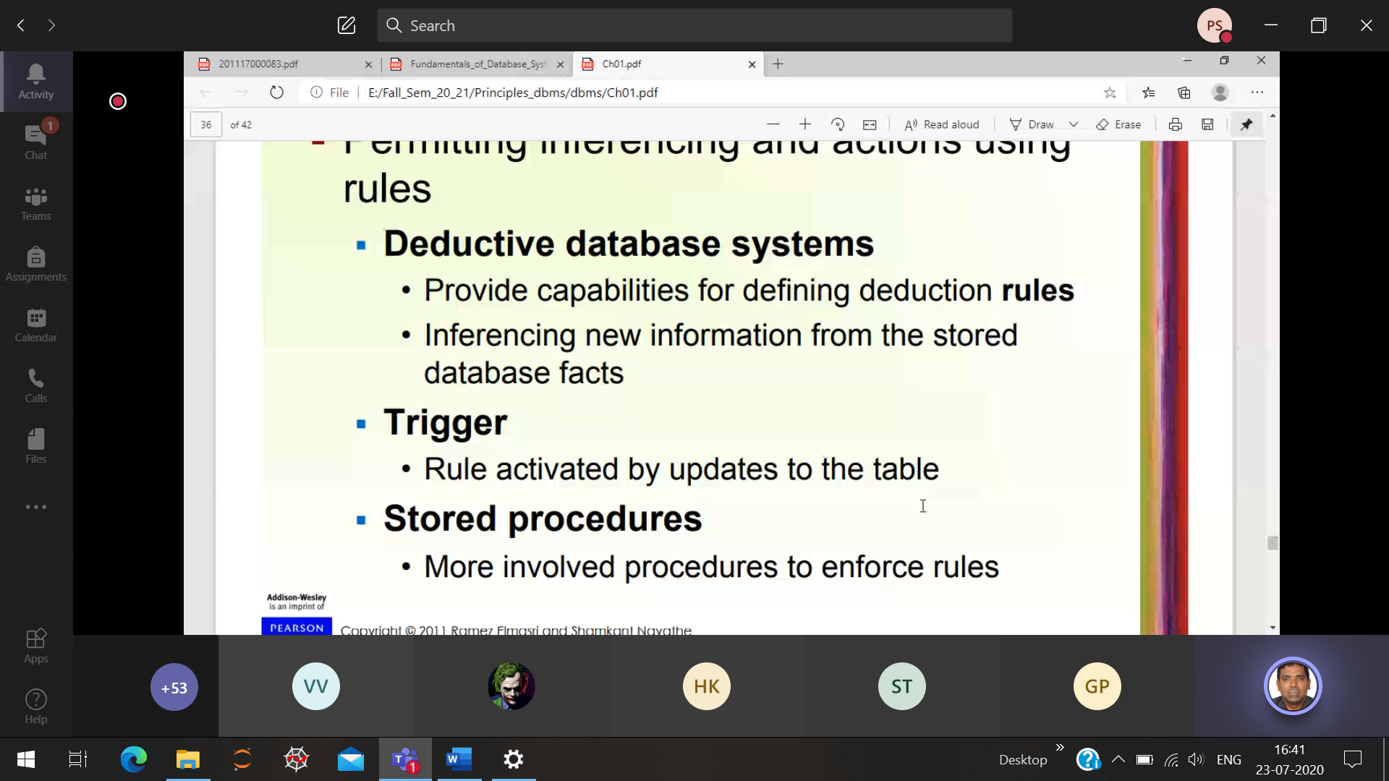

Eg: mega-mart : giving offers to the customer via sms.

28/7/20 (3 Schema architecture)

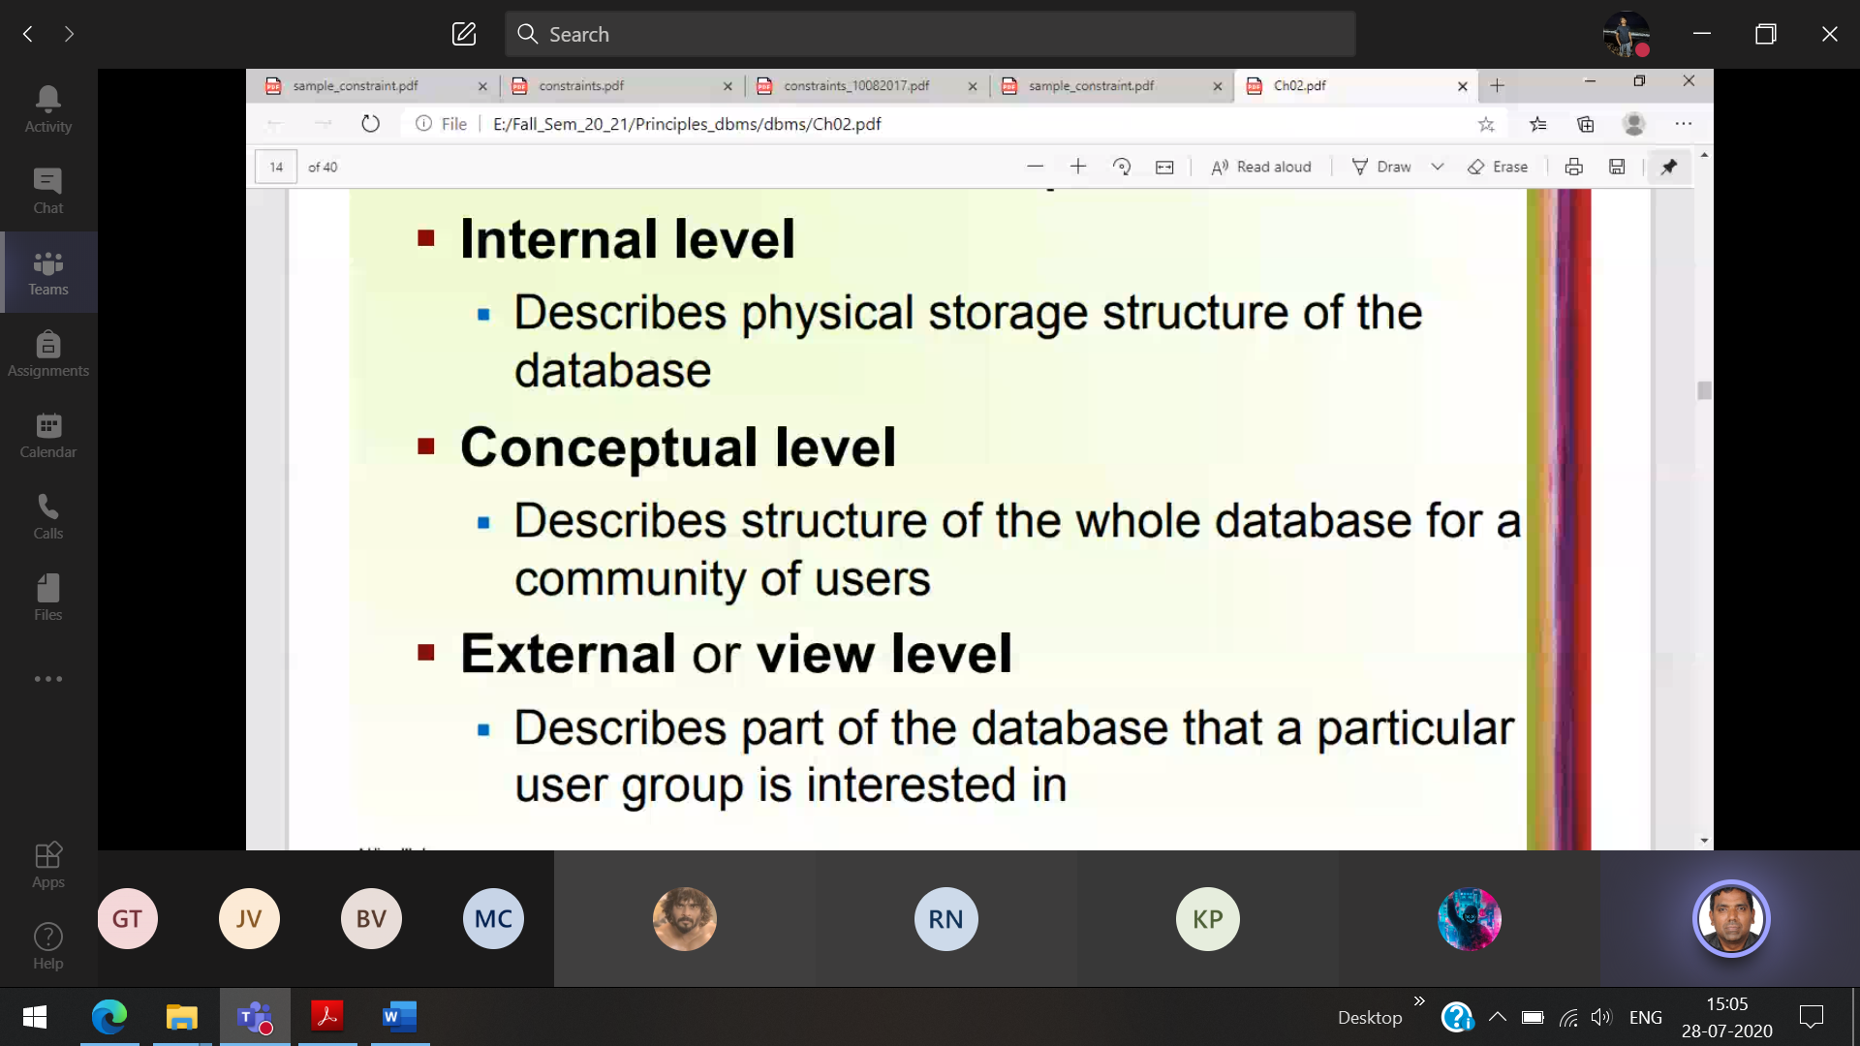

Internal schema : What kind of Data-structure is used to store and retrive the data

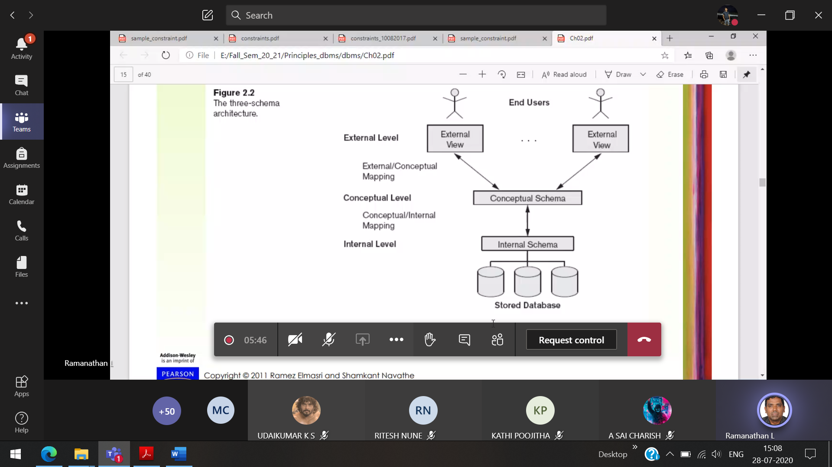

Internal schema handled by DBA

Changing the data-structure type, authorisation control ,conceptual schema the internal schema will not be affected.

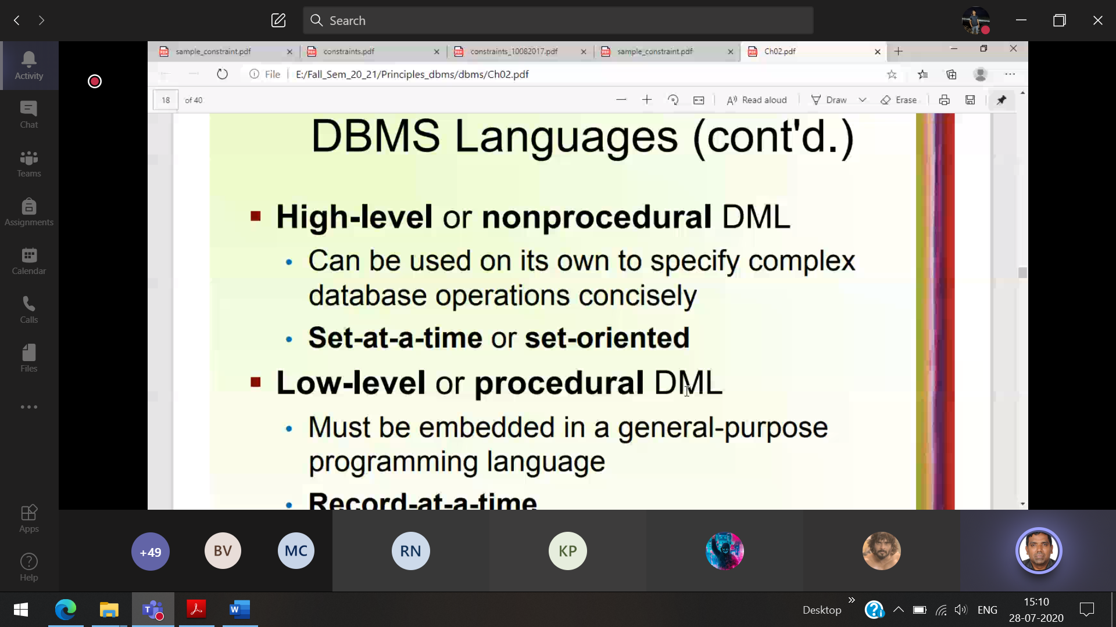

High level 🡪 Query   
Low level 🡪 Oracle connecting with the Data-base  
 Java connecting with the Data-base

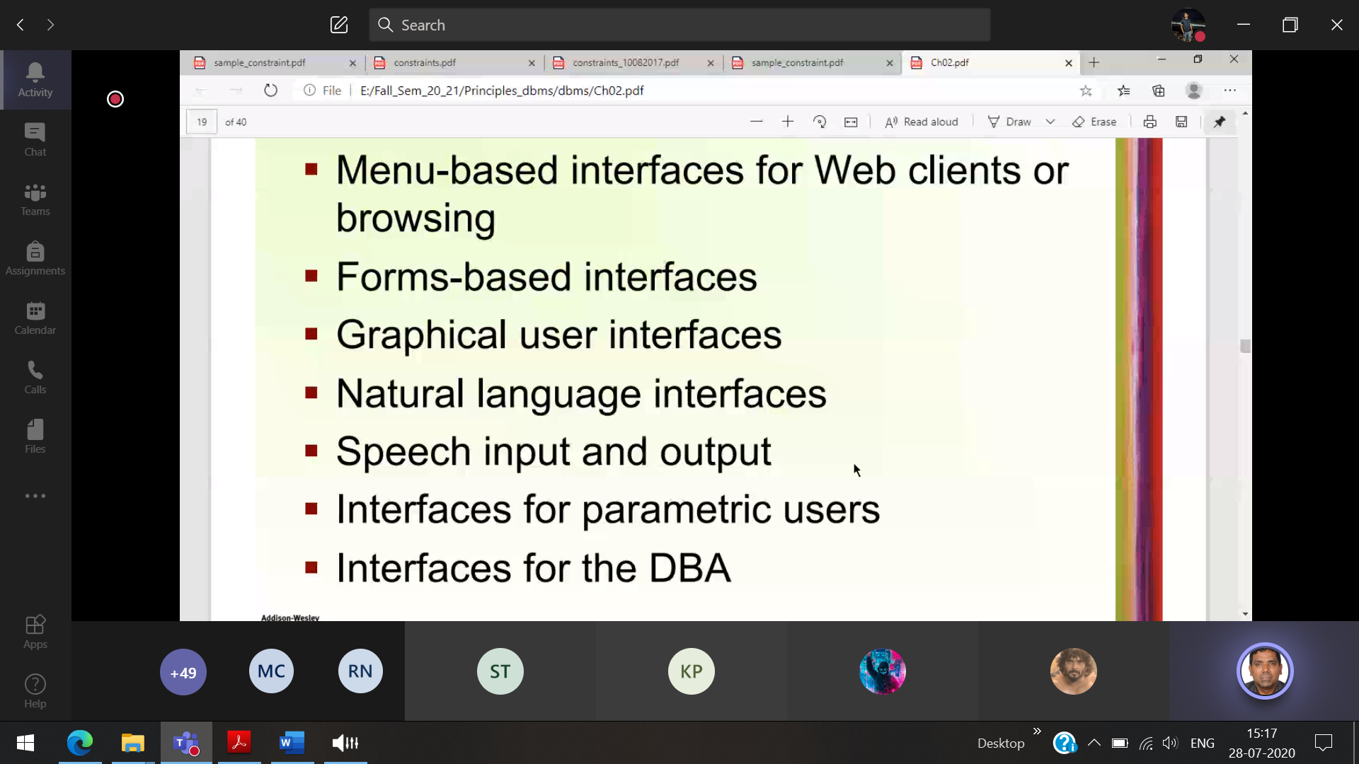

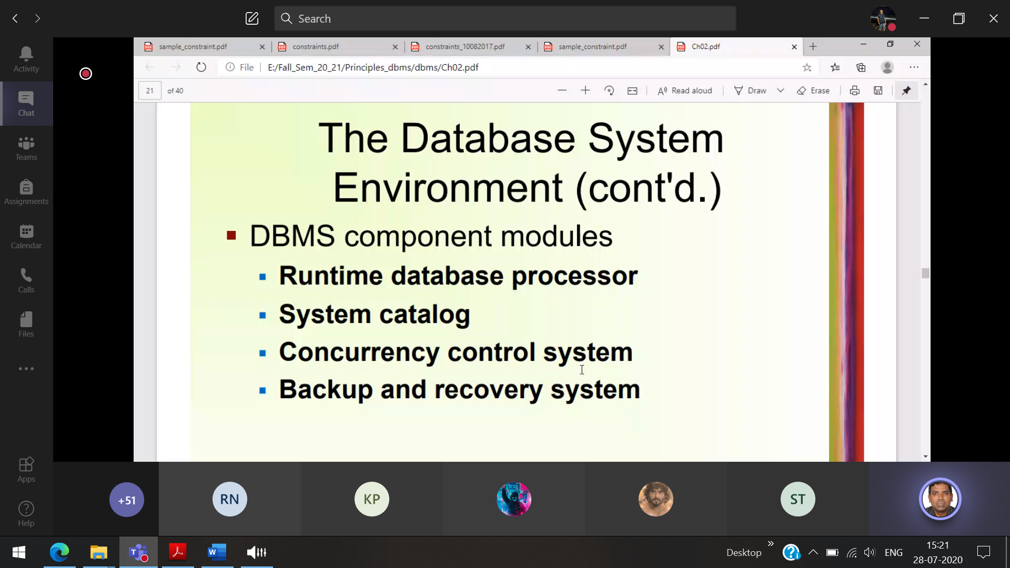

System catalog contains the schema  
Concurrency 🡪 Multi -user operating on the same data base(tatkal ticket)

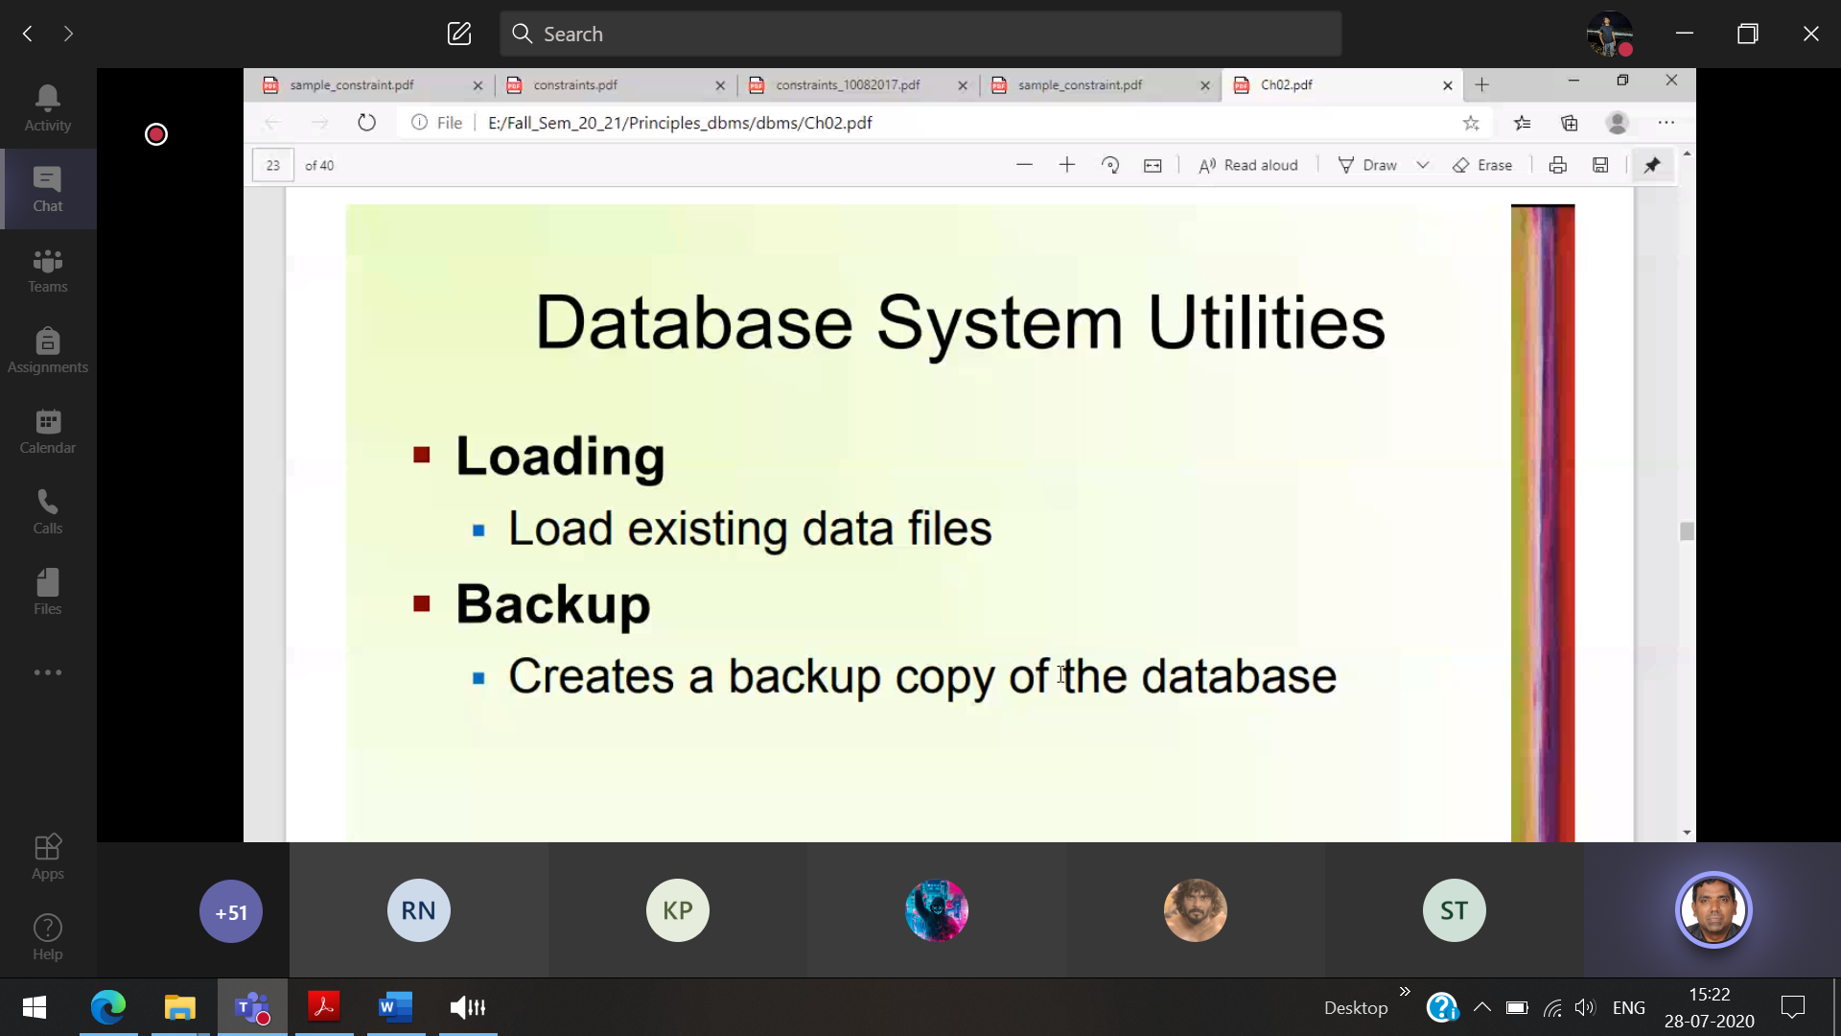

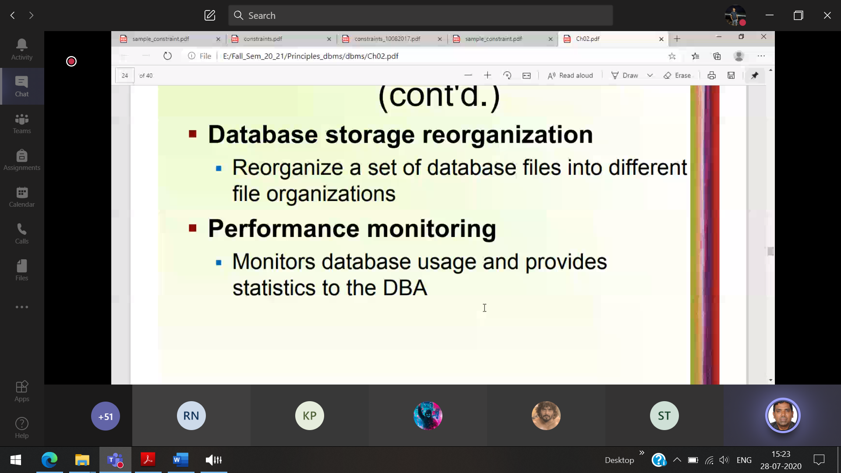

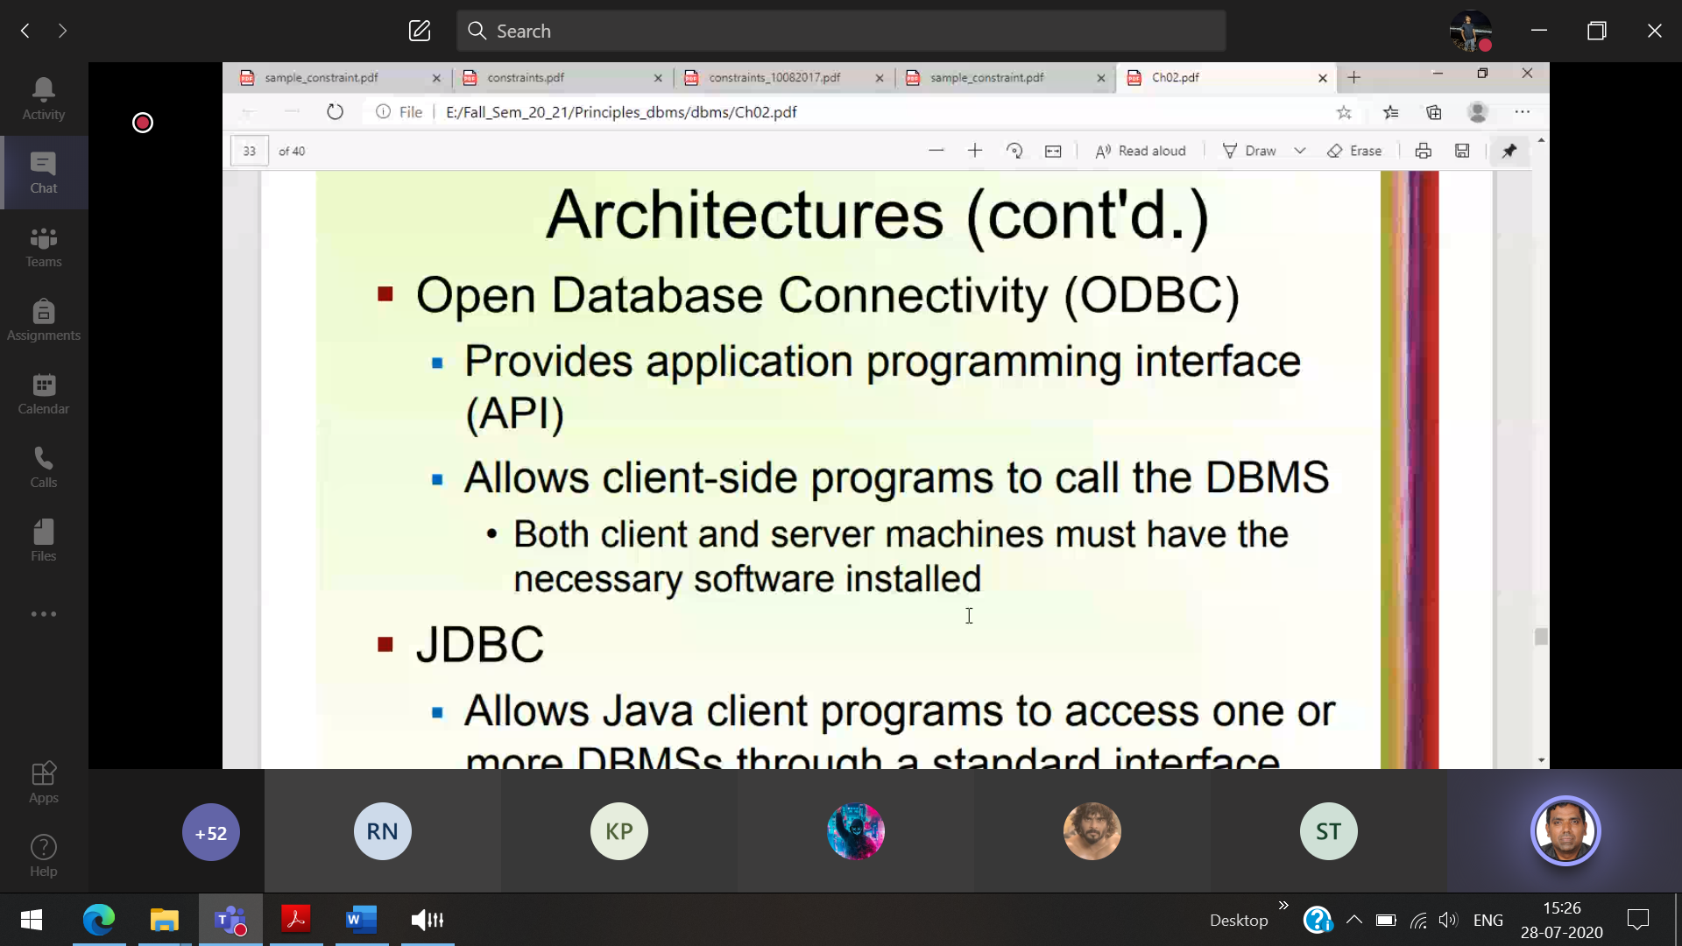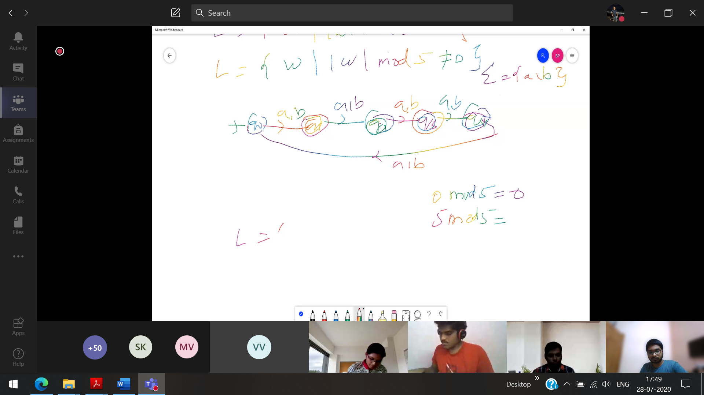

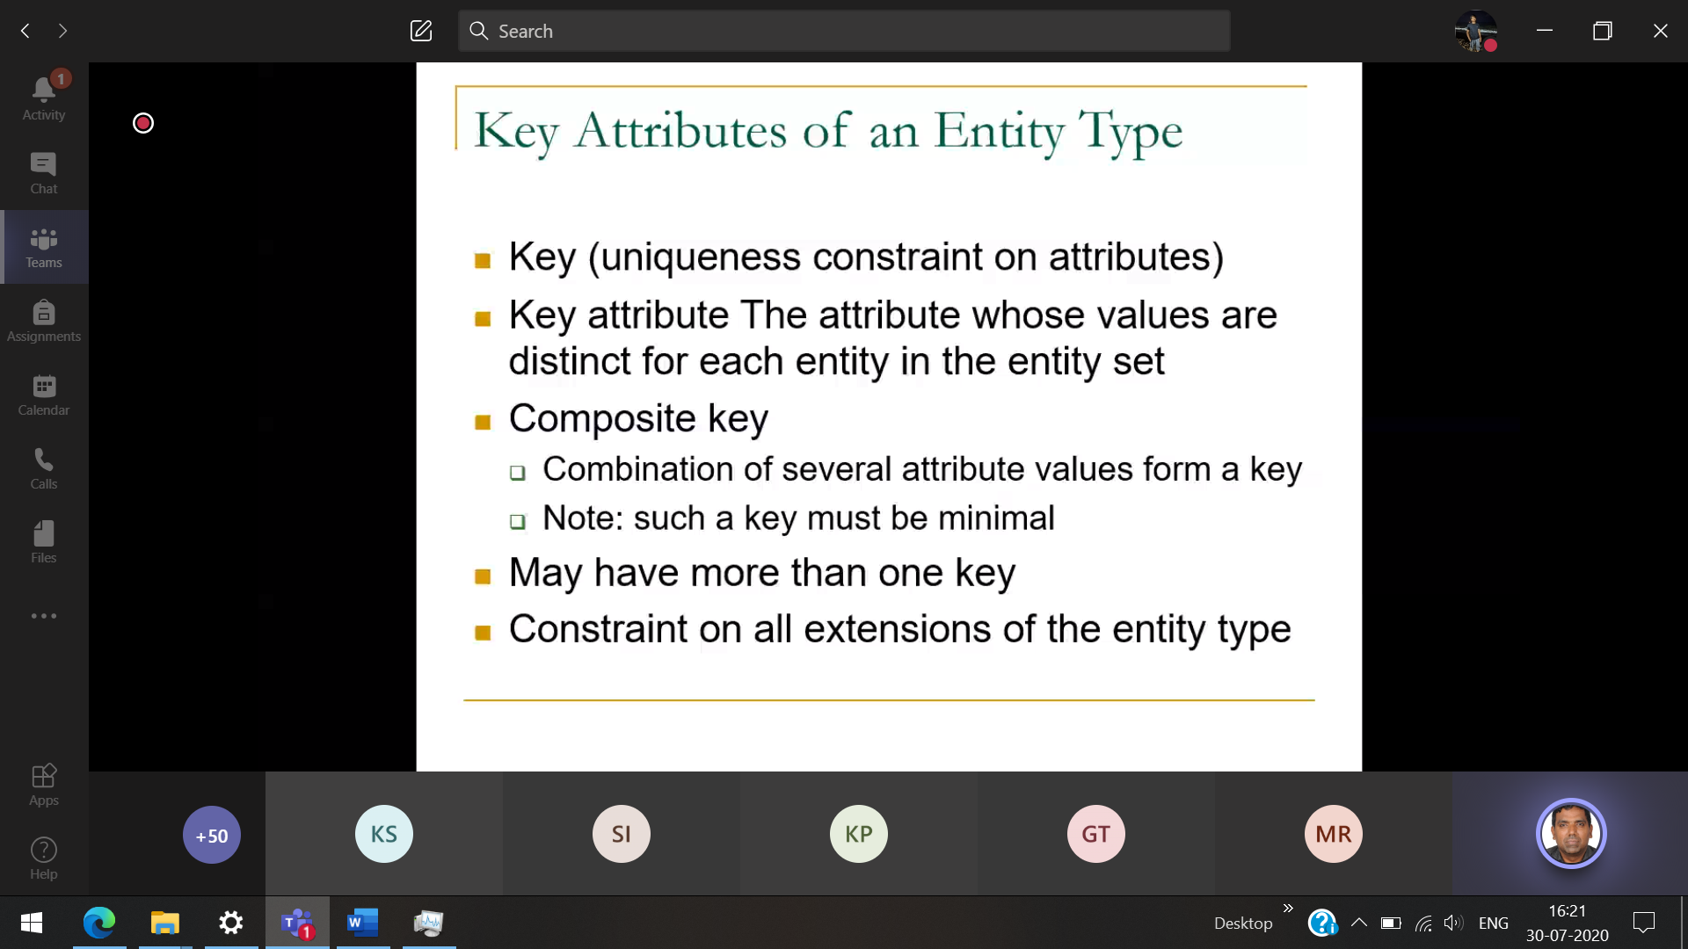A table can have only one primary key  
A table can have more than one unique key

